**DEPARTMENT OF COMPUTER SCIENCE AND**

**ENGINEERING**

**CS64: MINI PROJECT WORK**

**TERM: Jan-May 2020**

**MINI PROJECT SYNOPSIS**

**Submitted to**

**Ganeshayya Shidaganti**



**TEAM MEMBERS**

|  |  |  |
| --- | --- | --- |
| **Sl. No** | **USN** | **Name** |
| 1 | 1MS17CS007 | AMAN |
| 2 | 1MS17CS039 | HIMANSHU DAGDI |
| 3 | 1MS17CS041 | IKESH V |
| 4 | 1MS17CS042 | JAGDISH |

M.S. RAMAIAH INSTITUTE OF TECHNOLOGY

(Autonomous Institute, Affiliated to VTU)

# SYNOPSIS

**1. Title of the Project:**

IDENTIFICATION OF STUDENT GROUP ACTIVITIES IN EDUCATIONAL

INSTITUTE USING COGNITIVE ANALYTICS

## 2. Introduction (Introduction to the Area of Problem Statement)

Cognitive analytics is a field of analytics where we apply human-like intelligence to analyze various inputs to provide valuable insights. We can use cognitive analytics to identify patterns in student activities with respect to their group to gain information that can be used to improve student decision making.

## 3. Problem Statement

Assessing student groups to derive a correlation between student groups and their performance as individual and as a group, and how they evolve over time., to gain insights on how students interact and how they benefit from groups.

## 4. Objective of the Project

* To recognize the behaviour of the group as an entity, rather than the activities of the individual members.
* To model the behaviour of the individual group members, as well as the individual's roles and relationships within the group.
* To Identify the interests of the groups and establishing a relationship between the daily routine of students with their grade
* To extract student performance as an individual and as a group
* To identify how often students meet their teachers and come to the classroom.
* To determine how students spend time inside and outside the classroom

## 5. Motivation

Students spend a significant portion of their life in college, establishing a social bond with one another forming group which they spend most of their time in college. The group to which they belong becomes a major factor in their activities, academic performance and decision making. So we should have a good understanding of how students evolve with their team, which will help in bettering the students. And helping students who normally don’t engage in group activities by making them aware about the benefits of group engagement.

## 6. Existing System

Student-Group-Activity-Recognition:

The aim of the project is to see how group formation is taking place, how a particular group evolves over time, how the group breaks over time and correlation with the users of the group with their GPA. Also it aims to finding those users who are not participating in group formation and check whether the student has some issues, thus helping to introspect into the matter. The project considers only few parameters for analysis. And challenges not addressed include quantification of the behaviour and roles of individuals who join the group, integration of explicit models for role description into inference algorithms, and scalability evaluations for very large groups and crowds.

## 7. Proposed System

This project deals with looking into the activities of students of a college based on sensor data and adding it in the Data Set**.** The project aims to derive a relation between the student and his/her respective group and also finding out the students who are not participating in group formation and checking whether the student has some issues, thus helping the student in that matter. This project deals with how a student spends time in a class and how frequent the student comes to the class, also checking the routine of the student after the classes or in his/her free time and deriving the relation with their performance.This project deals with how group formation is taking place, how a particular group evolves over time, how the group breaks over time by keeping track on the movement of students over the campus/institute.

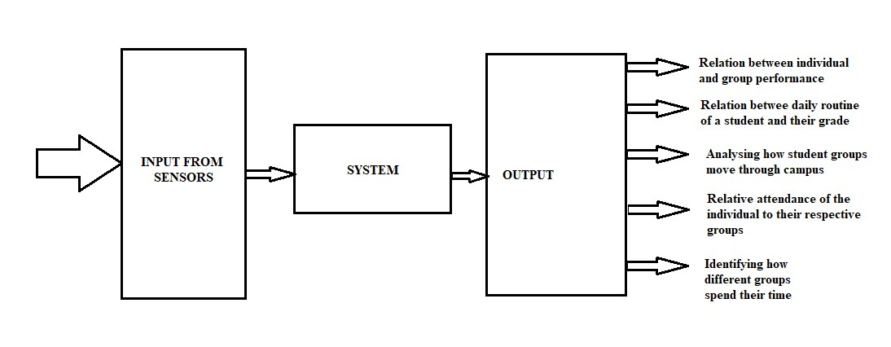

## 8. Hardware & Software to be used

* Accelerometer
* Wifi hardware
* Camera
* Python ide
* Python-libraries used:

1. Matplotlib
2. Plotly
3. Sklearn
4. Numpy
5. Statsmodels
6. CSV
7. RE

## 9. Social /Environmental Impact of the Project

Identifying those students who are not participating in group formation and checking whether they have some issues like anti-social behavior, depression.

Thus, helping us to introspect into the matter.

**Signature of the Guide**